Car Trawlers application – Car Website
1. Test Plan Identifier
File Name: Car Trawlers application _v1.0.doc
- Document Name: Car Trawlers application
- Date: 28-Aug-2026
- Location: CBIT, Hyderabad

2. Document History
REV | Author | Edits | Date
1.0 | Gorakanti Ajay kumar, Graduate Engineer Trainee | Initial Draft | 28/08/2026

- Introduction
I use Car Trawler application to search for and book cars at airports. Car Trawler application requires me to enter Pick-Up Location, Pick-Up Date and Time Drop-Off Location, Drop-Off Date and Time Drivers Age, Car Group, Currency and Country of Residence. I can also choose the Drop-Off Location option if the drop-Off Location is not the same, as the Pick-Up Location. After I fill in all the details I press the Search button. Car Trawler application checks the information I entered. If all is correct Car Trawler application shows me a list of cars that match my search on the page.
4. Test Items
Specifies what components/modules will be tested.
Example:
- User registration module
- User login
- Pick-up section
- Pick-up location – textbox
- Different drop-off location – checkbox
- Pick-up date – textbox
- Pick-up time – list box
- Drop-off section
- Drop-off location – textbox
- Drop-off date – textbox
- Drop-off time – list box
- Driver's age – textbox

5. Features to be Tested
Medium priority features are features that have been stable and High Priority features are features that have been recently changed.

Feature to be Tested | Priority | Comments
User Registration | High | Verify that the user can register with valid details.
User Login | High | verify that the user can login with valid credentials.
Pick-up section | High | verify that the Pick-up section is displayed correctly.
Pick-up location | High | verify that the user can enter a valid pickup location.
Different drop-off location | High | verify that the checkbox can be selected and deselected successfully.
Pick-up date | High | verify that the user can enter a valid date in dd/mm/yy format.
Pick-up time | High | Verify that the user can select a valid time list box in hr.min 24-hour format.
Email ID | Medium | Optional field; valid email format when entered.
Search Cabs | High
Search Results | High
User Logout | High

6. Features NOT to be Tested
- Internal implementation of third-party services not specified in Req 17.
- Payment processing and payment-gateway internal logic.
- Car booking confirmation/payment flow after cab search, unless directly impacted by the search result.
- Administrative database maintenance screens.
- Features outside the Outstation Cab Search requirement.
- Unspecified legacy or experimental modules not impacted by Req 17.
7. Test Environment

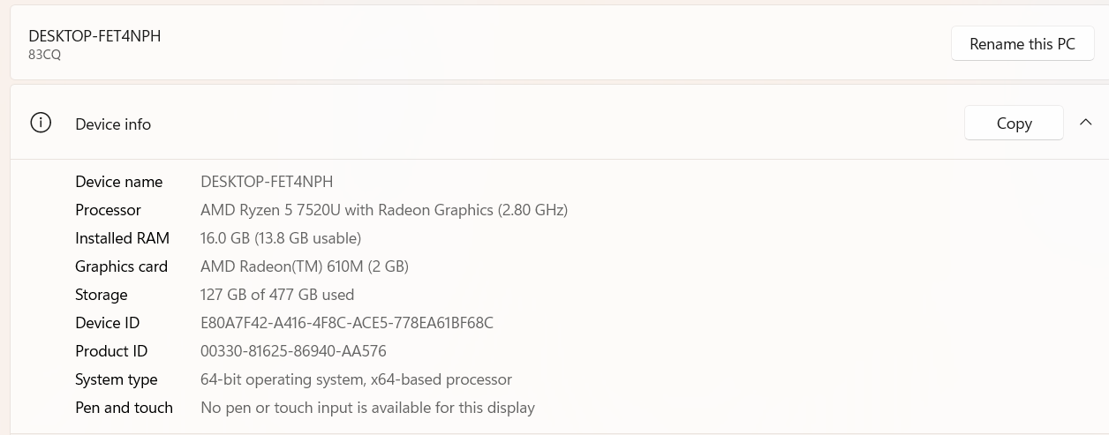

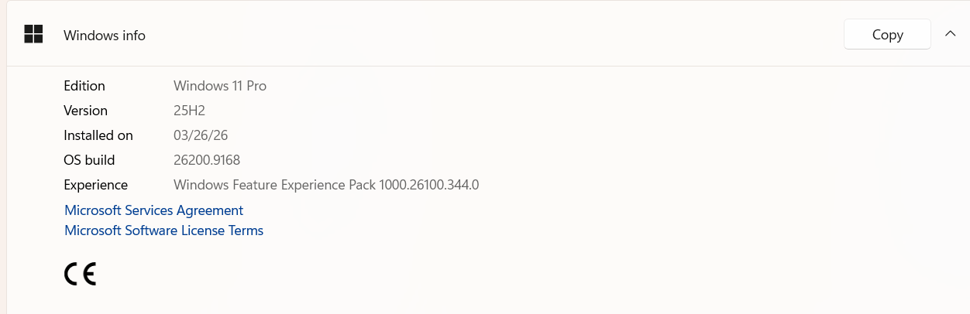
8. Test Approach / Test Strategy

Describes how testing will be performed.
The test strategy for Car Trawlers application will include manual testing with automated testing(Selenium With Java) where time/need permits. Automated testing will be used to test the basic Interface objects keyboard and mouse navigation or any redundant tasks best translated to automation. Automated testing will be limited to a Win-64 platform because of Automation tool limitations.
- Sanity test will include an very short battery of tests to ensure the Car Trawlers application runs/launches and can connect to the back end database(MySql /SQL Server 2025). Test execution will happen as individual component testing. These tests will be fully automated.
- Acceptance tests will include a short battery of tests that will only touch major features to ensure Car Trawlers application will operate smoothly at a basic level. These tests will be executed on Windows 11 Home Single Language. The goal will be to automate all of these tests.
- Full Functional tests will include a comprehensive test of all features listed in this document. These tests will be limited to the Windows 11 Home Single Language. These test will include automation with time allowing.

8.1 Types of Testing
- Smoke Testing
- Sanity Testing
- Functional Testing
- Integration Testing
- System Testing
- Regression Testing
8.2 Test Levels
- Unit Testing (by developers)
- Integration Testing
- System Testing
- Acceptance Testing
8.3 Test Techniques
- Black Box Testing
- Boundary Value Analysis
- Equivalence Partitioning
- Error Guessing Functionality Testing

Usability Testing
The usability testing will be accomplished by verifying the information in each window are accurate. Menus, icons and toolbar functionality will be tested as applicable to the navigation and results panes. Multi Window Overlapping will be tested because product supports opening of multiple documents.

Robustness/Reliability Testing
Test the GUI for correct keyboard and mouse navigation, windows, menus, buttons, etc. These tests will include Keyboard only navigation of Make trip application – Car, Mouse only navigation. Correctness and existence of warning/error dialog boxes. The correct/expected functionality of buttons, icons and menus.

Stress Testing
Not applicable

9. Entry and Exit Criteria
9.1 Entry Criteria
Conditions to start testing:
- Requirements approved
- Test environment ready
- Test data available
- Build deployed
9.2 Exit Criteria
Conditions to stop testing:
- All planned test cases executed
- Critical and high defects closed
- Test summary report prepared

10. Test Deliverables
Test plan Car Trawlers application _tplan.doc
Test Specification Car Trawlers application _tspec.doc
Test Automation Plan TBD()
Test Checklist TBD
Test Logs TBD
Test tools Selenium 4.47, Postman, Rest Assured, Jmeter, Jenkins, Git and Git Hub and Appium and MySql Server 2025

11. Testing Tasks & Resource Needs
  - Use of MySql Server database.
  - Write Test Specification.
  - Write Test Automation plan.
  - Write Test Checklist.
  - Setup workspace.
  - Develop Automation script.
- Minimum requirements for platforms:

12. Schedule
Test Documentation
Document | Development Time |  | Sign-off Date | Dependencies
 | Person-Days | Completion Date
Test Plan | 1day | 28/08/2026 | 28/08/2026 | Functional Spec. Review
Test Specifications | 1 day | 28/08/2026 | 28/08/2026 | Test plan, Functional Spec, Review
Test Logs | TBD | 28/08/2026
Test Summary Report | TBD | 28/08/2026
Checklist | TBD | 28/08/2026

Test Development
Deliverable | Development Time |  | Dependencies
 | Person-Days | Completion Date
Functional Test Suite | 1 | 28/08/2026
Automation build

Test Execution
Test Activity |  | Execution Time (Person-Days) |  |  | Dependencies
 |  | Alpha | Beta | FCS
Acceptance |  | 1 Day | 1 Day | 1Days
Functional | Functionality | 1 | 1
 | Usability | All High to Medium test cases
 | Robustness | All High to Medium test cases
 | Stress | All High to Medium test cases
 | Multi Inst. | All High to Medium test cases
Regression
Documentation Review |  | 1 | 1 | 1
Total Test Cycle |  | 1 | 1 | 1

13. Risks and Assumptions
Risks:
- Environment Instability: Delays in setting up the test environment could impact the schedule- VM is not working port no.-5103
- Resource Availability: Limited availability of testers could delay test execution.
- Late Requirement Changes: Changes in requirements during the testing phase could lead to additional testing efforts.
- Contingencies:
- Backup Resources: Have backup resources ready to join the testing effort if required.
- Flexible Schedule: Allocate buffer time in the schedule to accommodate unexpected delays.
- Regular Communication: Hold daily stand-up meetings to quickly address any issues that arise

14. Approvals \Sign of
POSITION  *Approval required | NAME | SIGNATURE | REVIEWED | APPROVAL
Project Manager | Gorakanti Ajay kumar | Ajay kumar
Project Manager |  |  | Raghavendra BN | Raghavendra BN
Client Approval | Coforge

